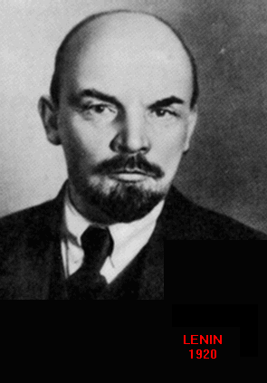 **Vladimir Illych Lenin** (1870-1924)

The brother of a man executed for participating in the plot to assassinate Alexander III, Lenin is the epitome of the modern revolutionary. In a lifetime of political agitation and argument, Lenin formed the political party which would successfully bring the first socialist government in European history into being

The Bolshevik (minority) wing of the Marxist Social Revolutionary Party broke with the Mensheviks (Majority) over conflicting interpretations of Marx’s “dialectical materialism.” Marx had argued that built into capitalism were the inevitable seeds of its own downfall. A highly developed capitalist economy must eventually collapse and bring into being a revolutionary worker’s state.

The Mensheviks believed that Russia would have to go through a stage of industrial capitalism before the revolution could take place. Lenin disagreed. He was not willing to wait.

Lenin believed that a revolutionary vanguard, a small group of ruthless and utterly committed revolutionaries, could topple the Tsar and institute a ‘dictatorship of the proletariat.’ These absolute rulers would then drive Russia quickly through the bourgeois stage of industrial development, consciously and quickly remaking the state into a socialist economy.

The state would command all economic decisions: setting commodity prices, wages and production goals for all industries and business. The state would collectivize all agricultural enterprise, manage labor and divide production among the people.

Lenin’s goal was to export revolution as well. In formulating an alternate model for modernization to capitalist imperialism, Lenin’s brand of Marxism became popular among countries throughout the 3rd World during the 20th century.